Purpose:
The purpose of this lab is to investigate the solar system, the earth’s rotation, lunar phases, solar and refracting telescopes, and the seasonality caused by the tilt of the earth’s axis. After this lab, the students will be able to demonstrate and apply these concepts:
• The Earth rotates from east to west. The sun seems to rise in the east, but we know that in relation to the earth, the sun is stationary and the earth’s rotation is what causes the moon, the sun and the stars to appear to move in the sky.
• The moon is the earth’s only natural satellite. It rotates once on its axis every time it revolves once around the earth, every 28 days. Using this knowledge, we can predict when we’ll see each phase of moon in the daytime or nighttime sky.
• Galileo invented the first refracting telescope like the one we make in the lab today. Objects appear upside down in our telescope because of the way light bends as it goes through the concave objective telescope lens.
• Our seasons on the Earth are not caused by how close or how far away we are from the sun, but instead how directly or indirectly the sun’s rays hit the Earth’s surface. Where the sun is most direct, the temperatures will be the warmest.

GPS Standards/Essential Questions:
S4E1. Students will compare and contrast the physical attributes of stars, star patterns, and planets.
- Recognize the physical attributes of stars in the night sky such as number, size, color and patterns.
- Compare the similarities and differences of planets to the stars in appearance, position, and number in the night sky.
- Explain why the pattern of stars in a constellation stays the same, but a planet can be seen in different locations at different times.
- Identify how technology is used to observe distant objects in the sky.

S4E2. Students will model the position and motion of the earth in the solar system and will explain the role of relative position and motion in determining sequence of the phases of the moon.
- Explain the day/night cycle of the earth using a model.
- Explain the sequence of the phases of the moon.
- Demonstrate the revolution of the earth around the sun and the earth’s tilt to explain the seasonal changes.
- Demonstrate the relative size and order from the sun of the planets in the solar system.

Essential Questions:
- What causes day and night? (Earth’s rotation)
- What causes seasonal change? (Earth’s tilt)
- Why are the locations and sizes of the planets important?
- Why is it important to be able to recognize the differences between stars and planets?
- How is technology used to help us see things far away?

Lesson Plan:
The lesson plan begins with an introduction by the Science Leader. The students will divide into four groups and rotate among four centers. At the end of the lab, the Science Leader will briefly review our conclusions.

Teachers:
Teachers: Please divide students into four even lab groups (if possible)…students will work in pairs at one activity center. Please be prepared to identify students who may not be photographed.

Parent Volunteers:
Please read this material, and arrive at the lab promptly to familiarize yourself with the experiment. Your roll will be to ensure safety and assist the students as they complete the lab presented by the Lab Coordinator. You will not be responsible for the class presentation, but it would be helpful if you read the information provided here before coming to the lab

Facilitator Introduction:
Welcome to Panther Pete’s Lab. Introduce yourselves and the parent volunteers. This is a special time for you and our parent volunteers to investigate the exciting things you are learning in your classroom. The experiments you do during your Lab visits are prepared and taught by your parents, and the equipment you use in this lab is purchased by the PTA, with money you helped raise!!

Brainstorming/Subject Review:
Brainstorm with students… You are studying lots of things about space in your classroom. Let’s see what you can tell me about what you have learned: (Just use two or three of these questions as time allows.)
- What is our closest star? (the sun)
- What is in the center of our solar system? (the sun)
- How many planets orbit the sun? (now eight) Try to name them in order.
- Which planet is the largest? (Jupiter)
- Which planet is the smallest and is actually no longer considered a planet? (Pluto)
- The big planets, like Jupiter, Saturn, Uranus and Neptune are made of mostly what? (Gas, we call these Jovian planets) The smaller planets are made of mostly what? (rock, we call these terrestrial planets)
- Which planet has rings of rocks and gas that circle it? (Saturn)
- What are two ways that the Earth moves? (Revolves and rotates)
- How many days does it take for the Earth to make one revolution around the sun? (365 ¼)
- How long does it take for the Earth to make one complete rotation? (24 hours)
- Is there anything that revolves around the Earth? (moon)
- Does anyone know how many days it takes the moon to make one complete revolution? (28 days) Do you know that it makes one complete rotation in 28 days too, so the same side of the moon is always facing us? We never see the backside of the moon.

Key Instruction Points:
In our lab today, you will investigate four aspects of astronomy. At one center, you will investigate the moon phases using yourself and our classroom as part of a big model. Scientists use models to better understand something that is too big for them to visualize, and this is a perfect example of that practice. In the next center, you will investigate how the tilt of the earth’s axis causes the season. You will find that the sun is actually closer to the Earth in the winter, but that the actual distance between the Earth and the sun is not what most dramatically affects our seasons. In the third center, you will learn about Galileo and the first refracting telescope he invented. To best understand his telescope, you will construct one that works just like the one Galileo invented, magnifying the stars and planets sixteen times. At the fourth center, you will create a model of the solar system. Safety precautions: At the season center, do not touch the lamp or the bulb, as they could be very hot. At the telescope center, follow the directions carefully and do not use the telescopes to look directly into the sky during the day. Never should you look directly at the sun, either with your eyes or a telescope, as this will cause permanent damage to your retina.

Now you may divide the class into the four centers, taking about 10 to 12 minutes per center.

Center 1 Description: Moon Phases
Use the globe and review the difference between revolution and rotation of the earth. The earth rotates while it is revolving around the sun. One full rotation (spinning on its axis) of the earth takes 24 hours, or one day. One full revolution (via an elliptical-shaped path around the sun) takes 365 ¼ days, or one year.
Explain to the students that while the earth is moving about the sun (rotating and revolving), it has a moon that also moves about the earth. The moon revolves around the earth, and because of its movement, different parts of the moon are illuminated at different points of its path around the earth. The different parts you see of the moon are called phases.
Explain to the students that the movement of the moon, or its revolution around the Earth, makes the moon appear as if it is changing shape in the sky. This is caused by the different angles from which we see the bright part of the moon’s surface. What you see when you look at the moon depends on its location in relationship to the sun and Earth. We see a different fraction of sunlight being reflected from the moon to Earth. Of course, the moon doesn’t generate any light itself; it just reflects the light of the Sun.
Ask all the students to stand in the center of the room and pretend they are the Earth. Tell the students they will be facing the moon as it revolves around them/the “Earth”. You the leader should take the styrofoam moon and stand at the New Moon position (with the Sun poster hung on wall behind them). Explain to the students that the white half of the moon is facing the sun, away from the earth, in this New Moon position. Now take the styrofoam moon and move to the next (waxing crescent) moon position. Every time the moon stops, the “Earth” students observe the moon from the viewpoint of the earth and its angle from the sun. Repeat this at all 8 positions of the moon phases (hung on wall) around the “Earth.” Remind the group that this path takes 28 days. Important point: The part facing the sun never changes; the white half (illuminated half) of the moon always faces the sun, the dark side of the moon always faces away from the sun. However our position on the earth only allows us to see the illuminated portion of the moon at certain angles, which is why we see different moon phases.
If the moon is lighted on the right side, we know that each night it will have more of its surface lighted than the previous night. (We might say that it is getting bigger; in science we call that waxing.) If the left side of the moon is lighted, we know that the next night we will see less of its surface lighted. (So it will look smaller; in science we call that waning.) Remember that when you see the right side of the moon lighted, the moon is waxing, and the next night, more of the surface will be lighted. When the left side of the moon is lighted, it is waning, and the next night, less of the surface will be lighted. (There is a chart illustrating the phases of the moon that you can show the students during this exercise.)
You may want to repeat this activity one more time around to reinforce and “quiz” them on the moon phases.
* * *
Volunteer Notes:
The enlarged moons represent what we see from earth during each phase of the moon. The line passing through each small moon shows the half which faces the earth. 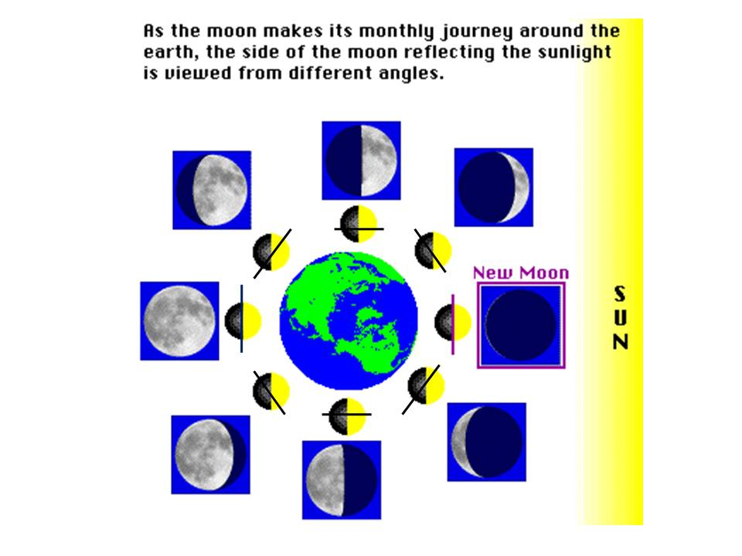

The moon’s cycle repeats itself every 28 days. The phases always follow one another in the same order: New Moon, Waxing Crescent, First Quarter Moon, Waxing Gibbous, Full Moon, Waning Gibbous, Third Quarter, Waning Crescent. (The cycle then repeats: New Moon, Waxing Crescent, etc.)

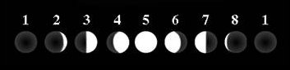
(1) New Moon - When the Moon is roughly in the same direction as the Sun, its illuminated half is facing away from the Earth, and therefore the part that faces us is all dark: we have the new moon
(2) Waxing Crescent Moon - As the Moon moves around the Earth, we get to see more and more of the illuminated half, and we say the Moon is waxing. At first we get a sliver of it, which grows as days go by.
(3) First Quarter Moon - A week after the new moon, when the Moon has completed about a quarter of its turn around the Earth, we can see half of the illuminated part; that is, a quarter of the Moon. Sometimes referred to as “Quarter Moon.”
(4) Waxing Gibbous Moon - During the next week, we keep seeing more and more of the illuminated part of the Moon, and it is now called waxing gibbous (gibbous means "humped").
(5) Full Moon - Two weeks after the new moon, the moon is now halfway through its revolution, and now the illuminated half coincides with the one facing the Earth, so that we can see a full disk: we have a full moon. (If the Moon happens to align exactly with the Earth and Sun, then we get a lunar eclipse.)
(6) Waning Gibbous Moon - From now on, until it becomes new again, the illuminated part of the Moon that we can see decreases, and we say it's waning. The first week after full, it is called waning gibbous.
(7) Third Quarter Moon - Three weeks after new, we again can see half of the illuminated part. Also called “Last Quarter Moon.”
(8) Waning Crescent Moon - Finally, during the fourth week, the Moon is reduced to a thin sliver from us, sometimes called waning crescent.
A while after four weeks the illuminated half of the Moon again faces away from us, and we come back to the beginning of the cycle: a New Moon.

Center 2 Description: Telescope
Review with students that astronomers study space with optical telescopes. Galileo invented the first telescope hundreds of years ago. It was a refracting telescope.
Today we are going to make a simple Refracting Telescope, similar to the one Galileo himself made. A Refracting Telescope is a telescope that uses a convex objective lens to focus light directly into an eyepiece lens which then magnifies an image.

Activity: Hand each student one small diameter cardboard tube, one large diameter cardboard tube, one thin (larger) lens that is inside a red cap, and one thicker (smaller) lens protected inside a circular piece of gray foam. Have each student place their larger lens with the red cap on one end of the larger diameter cardboard tube. Next, have students place their smaller lens with the gray foam circle into one end of the smaller diameter cardboard tube.

Have students carefully slide the open end of the smaller diameter cardboard tube into the open end of the larger diameter cardboard tube. Students should hold their telescope up and look through the end opposite the red end. Have students focus on a far off object in the room (maybe one of the planets hanging from the ceiling or a poster on the wall) by sliding the small tube in and out of the larger tube until the image they are viewing is in focus.

Ask the students: How do objects appear through the telescope? Objects will appear upside down and larger.

Allow the students to play with telescopes and view different objects at their own pace.

Center 3 Description: Seasons and the Sun
Volunteer notes to discuss during activity:
- The seasons result from the Earth's axis being tilted to its orbital plane. The Earth’s axis is tilted at 23 ½ degrees. If the Earth were not tilted, we would never have seasons. The same amount of sunlight would always hit each portion of the earth.
- Revolution (along with the earth’s tilt) is what gives us the different seasons. (Rotation causes day and night).
- Because of the earth’s tilt, at any given time during summer or winter, one part of the planet is more directly exposed to the rays of the Sun. Therefore, at any given time, the northern and southern hemispheres experience opposite seasons. When it is summer in the Northern Hemisphere, it is winter in the Southern Hemisphere, and vice versa. The Earth’s North Pole is tilted toward the sun in our summer months, and away from the sun in our winter months.
- Countries close to the Equator will experience little if any change in seasonal temperatures because their distance to the sun and exposure to direct rays of the Sun remains more constant. The area bounded by the Tropic of Cancer 23.5 N and Tropic of Capricorn 23.5 S of the Equator is known as the "tropics." This area does not experience seasons because the sun’s rays are always much more direct there. Only higher latitudes, north of the Tropic of Cancer and south of the Tropic of Capricorn, experience significant seasonal variation in temperature.
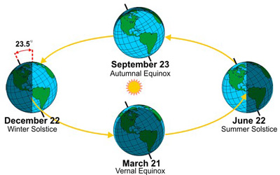

Activity: Place 2 desk lamps back to back facing out toward 2 flat wooden globes. One represents our summer and the other our winter. Place 5 digital thermometers pointing out towards the lamp through the slots at equator, 30° and 60° N & S in each wooden globe. Thermometer probes should be 6-8 inches from the light source.
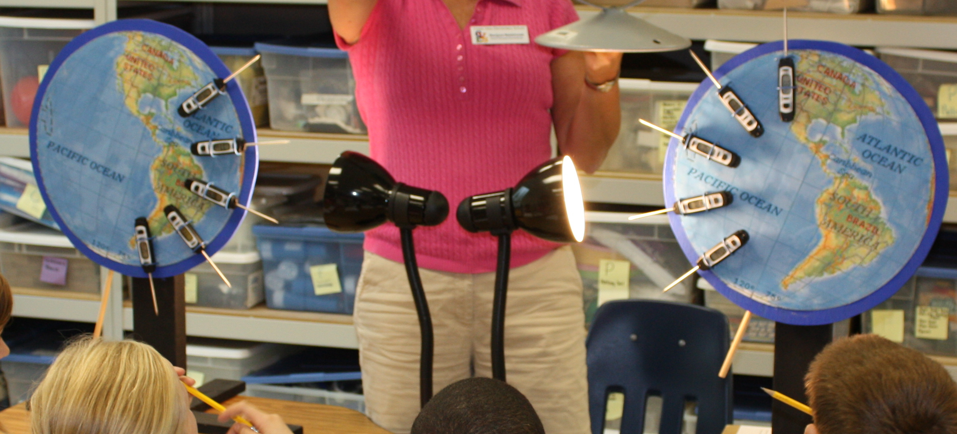
- Turn on the light, cautioning students not to touch the light. (You turn it on and off, not the students!)
- Watch the thermometers for three minutes and then record the ten temperatures on your data sheet. (While waiting, use globe to discuss points).
- Temperature readings at each latitude position will be different but not drastically. Even if the difference is 1-2 degrees or less it should be enough to identify a pattern.
- Using a globe, demonstrate how the earth’s tilt combined with its revolution around the sun (in this case lamps) creates our seasons.
- Comment on how countries in opposite hemispheres have opposite seasons (i.e. Australia’s summer is our winter and vice versa), and how countries close to the equator will have more constant temperatures and little seasonal changes in temp.

Center 4 Description: Model of the Solar System
How big is space? That is a question man has been asking since the beginning of time. When your grandparents were in school it was thought that the Universe was small--perhaps only 5000 light years across. 500 years ago it was thought that the Universe was only a little bit bigger than the Earth. In modern times with the power of technology we are finally starting to grasp the immense size of the Universe, and it is much bigger than anyone could have ever imagined.
This activity helps demonstrate the immense scale of our solar system. The sizes of the planets vary greatly as do the distances between planets and their distance from the Sun. Explain to the students that you will be helping them to make a scale model of the solar system.
- Discuss the order of the planets from the sun. Remind students of the memory trick to remember the order of planets: My Very Excellent Mother Just Served Us Nine Pizzas. (And yes, Pluto has been diminished in ranks to a “dwarf planet,” but tell students that for tradition’s sake we’ll keep talking about it.)
- Show the students the die-cut planets so they don’t see the labels on the back. See if the students can guess, based on the relative sizes, shapes, colors of the planets which planet is which. Reinforce the vast difference in sizes of the planets, especially between earth and the gas-planets: Jupiter, Saturn, Uranus and Neptune. 1300 earths could fit inside of Jupiter! Also mention that the Sun is about 10 times as big as Jupiter and 100 times bigger than Earth! To illustrate this, point out the long strip of yellow paper across the front wall representing the diameter of the sun to scale with the rest of our model planets. Also, show them the laminated sheet with relative sizes of planets and sun.
- Demonstrate the vast size of our universe. (This activity is best done outside on the sidewalk or, if poor weather, very quietly in the hallway.) Give each student one (or 2) of the strings labeled with a planet name. (Note: Neptune & Pluto do not have a string). Have the children carry their string with them outside. Choose a wall and explain to them that for the purposes of this distance model we will assume that the wall represents the sun’s “edge”. Begin to have the students recall the order of the planets. In that order, one at a time, have the student with that planet’s string stretch out their string with one end at the edge of the wall/sun while you/someone hold it. Once their string is stretched out, they should leave it laying on the ground while the next planet/student goes. Repeat this until you get to Uranus. Then, for Neptune and Pluto you will estimate without a string to measure. Start with Pluto by doubling the distance from the sun as Uranus. Have a student pace it out and stand at Pluto’s distance. (Hint: helps if, in advance, you have a sense of a marker as to where Pluto should be placed). Then, Neptune is approximately half way between Uranus and Pluto – have a student stand there. Some children may end up doing more than one planet.
- Discuss how these distances from the sun for each planet are an accurate scale model.

Conclusion:
During the last five minutes, the Science Lab Coordinator will review what the students discovered.

Lab Set-Up & Materials:
Earth Rotation Center:
Sun poster on one wall
7 moon phase pictures (not including New Moon) hung on the wall at even intervals around the room.
Large Styrofoam ball, ½ painted black, mounted on long wooden dowel
Moon phase chart (on wall)
Globe
Telescope Center:
Starlab refracting telescope kits for each student at the center
Sun and Seasons Center:
Two wooden or styrofoam 12” disks, marked with axis, equator, home town, north and south poles, and latitude lines at equator, 30 and 60 degrees N & S
Two wooden platforms
10 digital thermometers poked through the equator and the 30 and 60 degree N & S latitude lines.
Two lamps with 100 W bulbs (on stands to project directly on the disks)
Globe
Model of the Solar System Center
Planet die cuts
Planet strings
Sun sliver/edge hung across a wall
For purposes of replacing die cut planets, the scaled measurements are below:

Planet | Scale Diameter | Planet | Scale Diameter
Mercury | 1 in | Saturn | 25 in
Venus | 2 5/8 in | Uranus | 10 in
Earth | 2.3/4 in | Neptune | 9 3/4 in
Mars | 1.5 in | Pluto | 1/2 in
Jupiter | 31 in

For purposes of replacing string for distance, the scaled measurements are below:

Planet | Scale Distance from the Sun | Planet | Scale Distance from the Sun
Mercury | 20 cm | Saturn | 470 cm/185 in
Venus | 40 cm | Uranus | 960 cm/378 in
Earth | 50 cm | Neptune | 1500 cm/590.5 in
Mars | 80 cm | Pluto | 2000 cm/787.4 in
Jupiter | 260 cm/102.4 in

